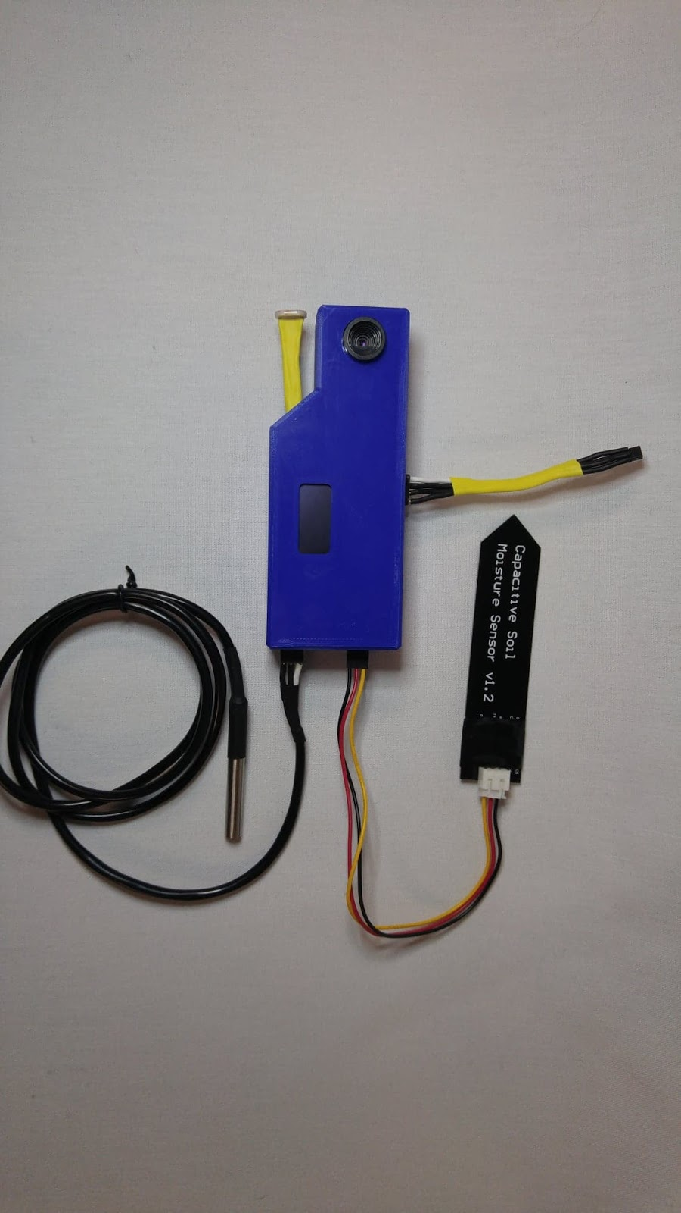

fresh view

User Manual

Applied Research Project

Dec 7, 2018

Recipient: Mel Dundas

By: Urban Fresh

Pawan Kumar  
Solomon Lindsay  
Varun Prabhakar

Table of Contents

Introduction 6

Materials 5

Instructions 6

Set Up 6

Hardware 6

Software 8

Access to Online storage 10

Conclusion 11

# Introduction

Fresh View is an automated plant monitoring system which helps you to keep an eye on your plants. This product senses the kind of environment your plant is in and if connected to a control unit, removes any headache to actually take care of the plant. This is a complete guide about getting started with Fresh View. There are step by step instructions on how to set up the device and the mobile app.  
  
Fresh View basically consist of two parts, first is the setting up the device in your planting area, and second is setting up the internet connection and app.

After setting the module you can log on to the firebase and see all the data taken by the module. Firebase is a very large storage system for data and pictures. You have access to this because if you want to look at the growth process of the plant and monitor the environment conditions of the plant growing up and keep record.

# Materials

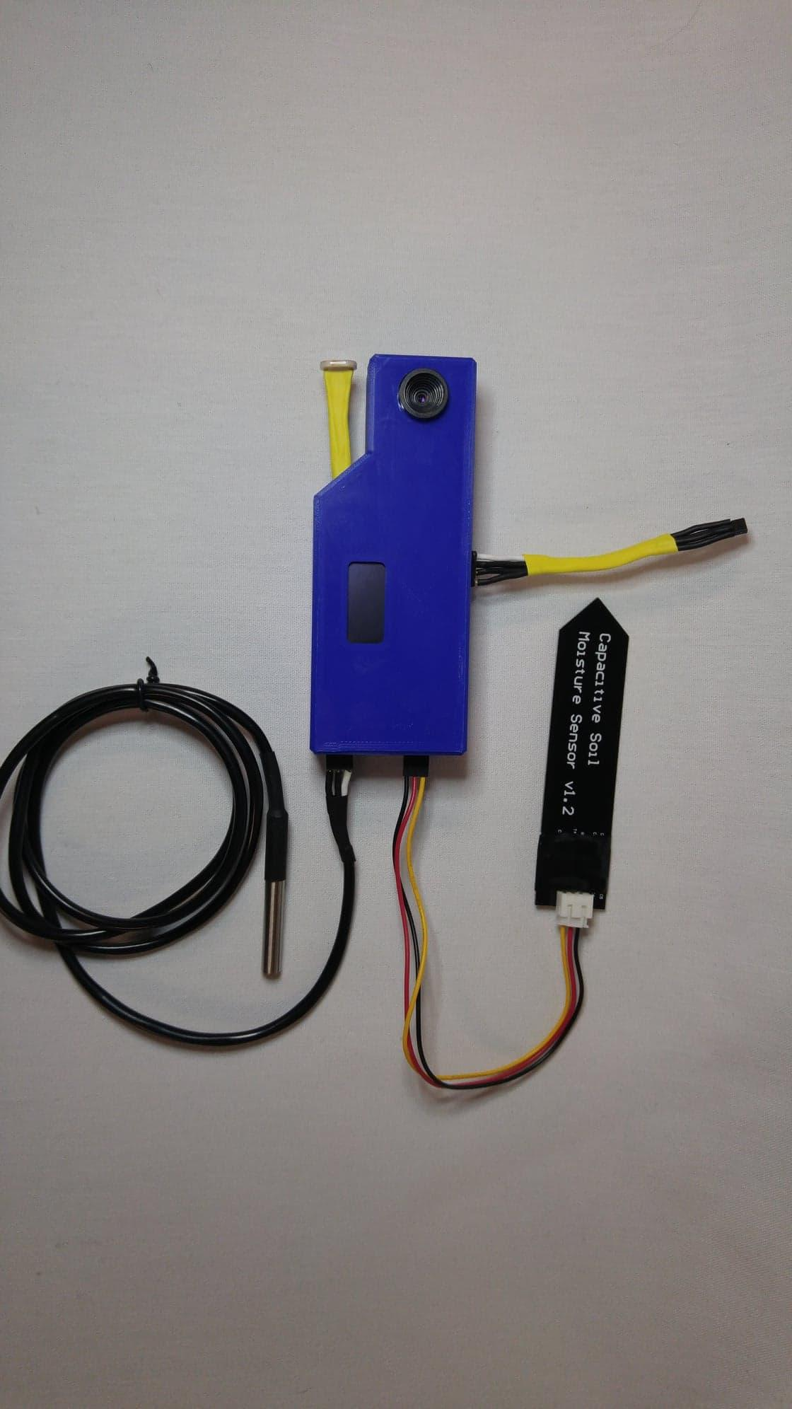

Figure 1: Fresh View Monitoring Unit

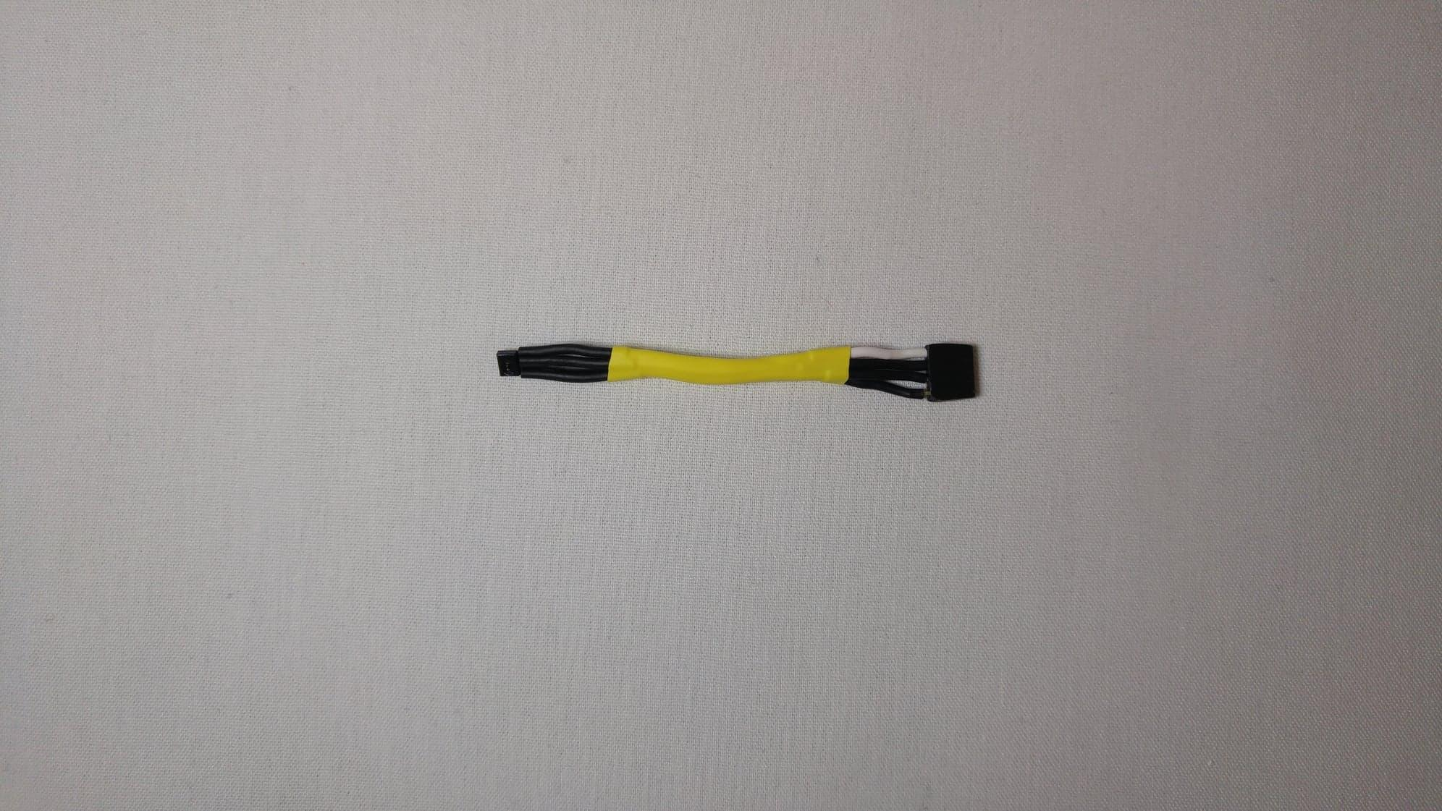

Figure 2: HIH7120 Temperature/Humidity Sensor

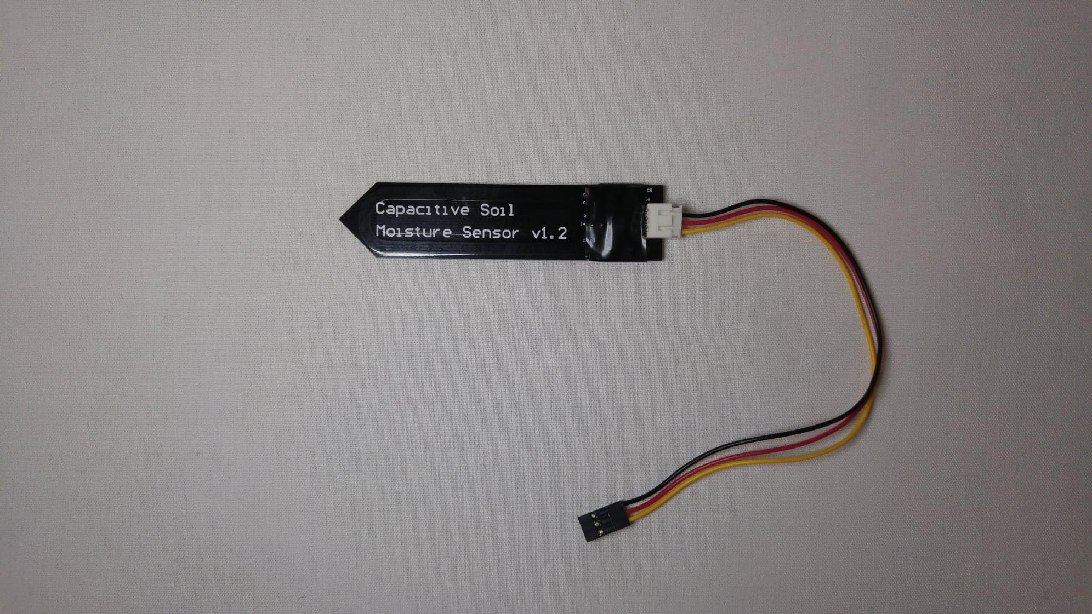

Figure 3: Capacitive Moisture sensor

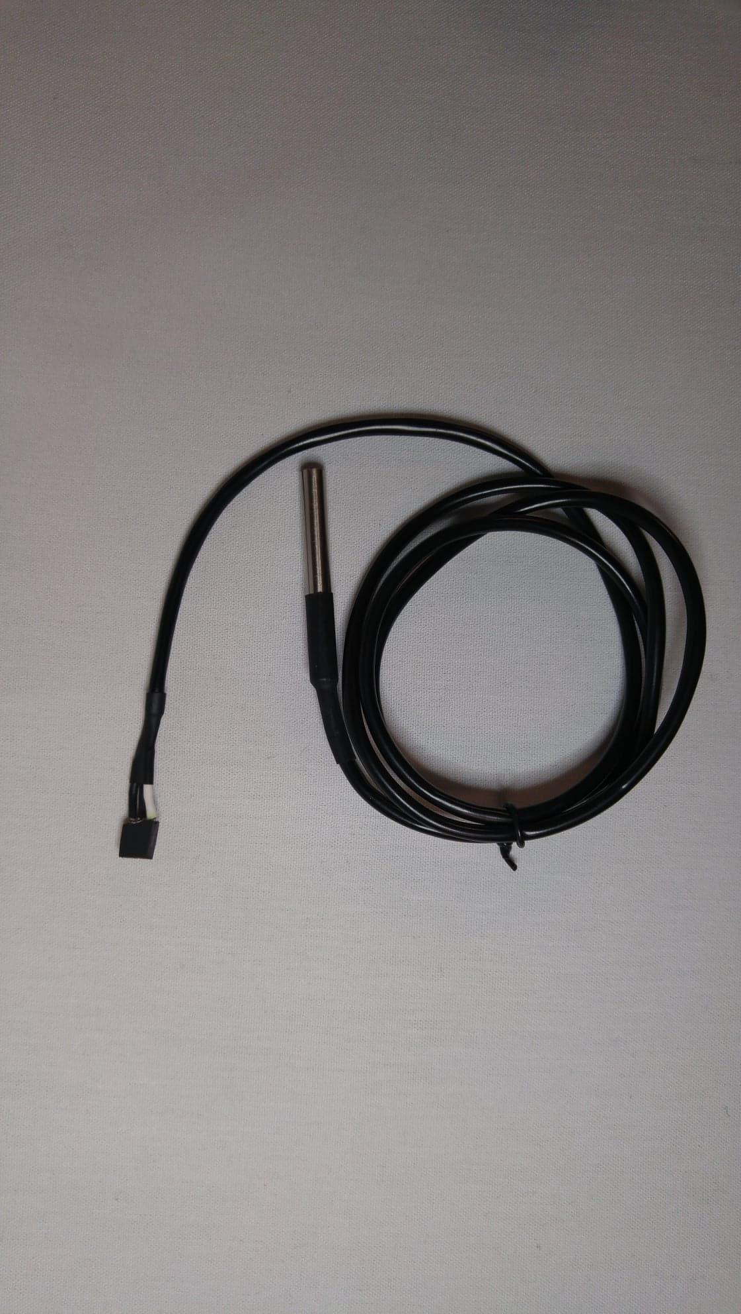

Figure 4: Water temperature sensor

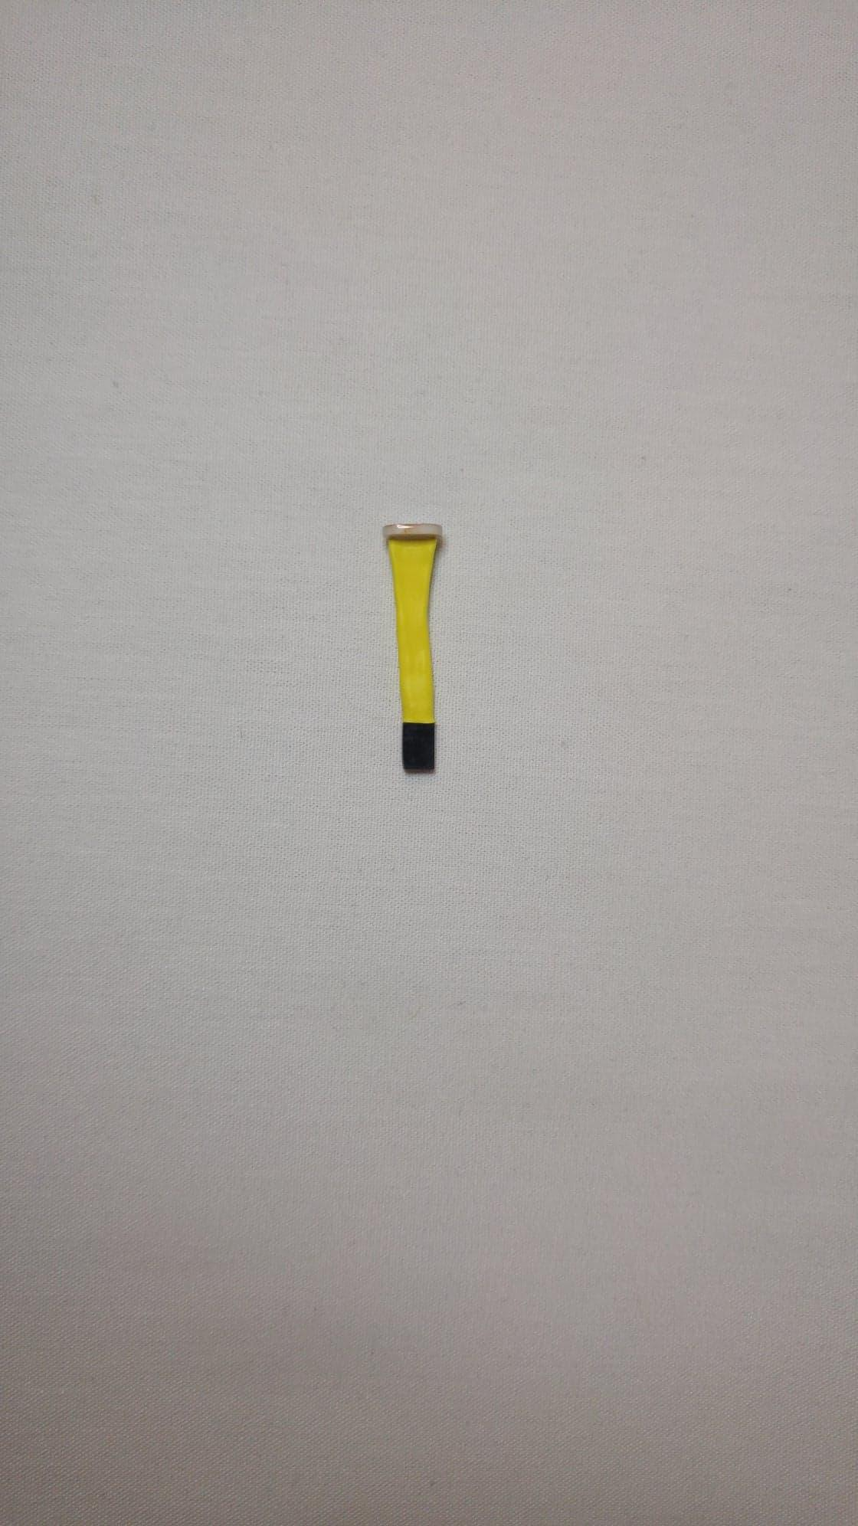

Figure 5: Light intensity sensor

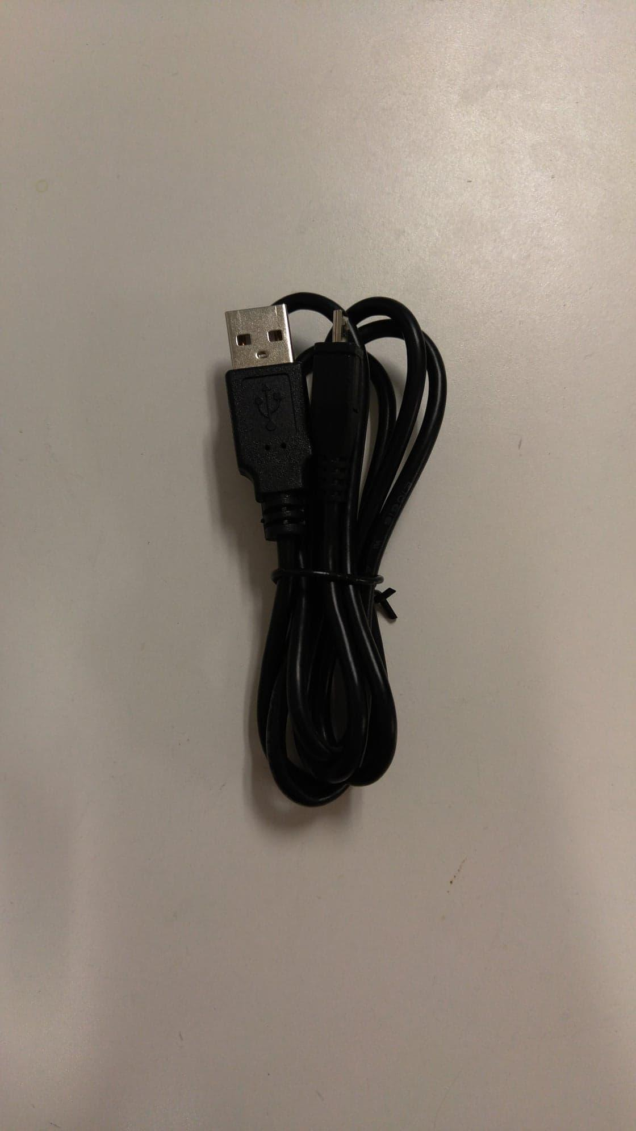

Figure 6: Micro USB Cable

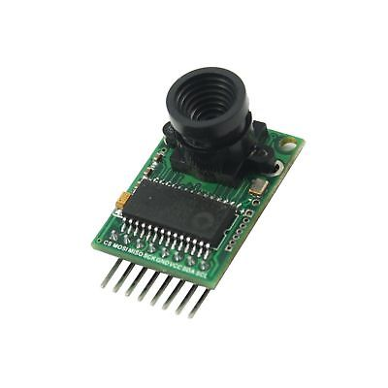

Figure 7: Arducam Camera Module

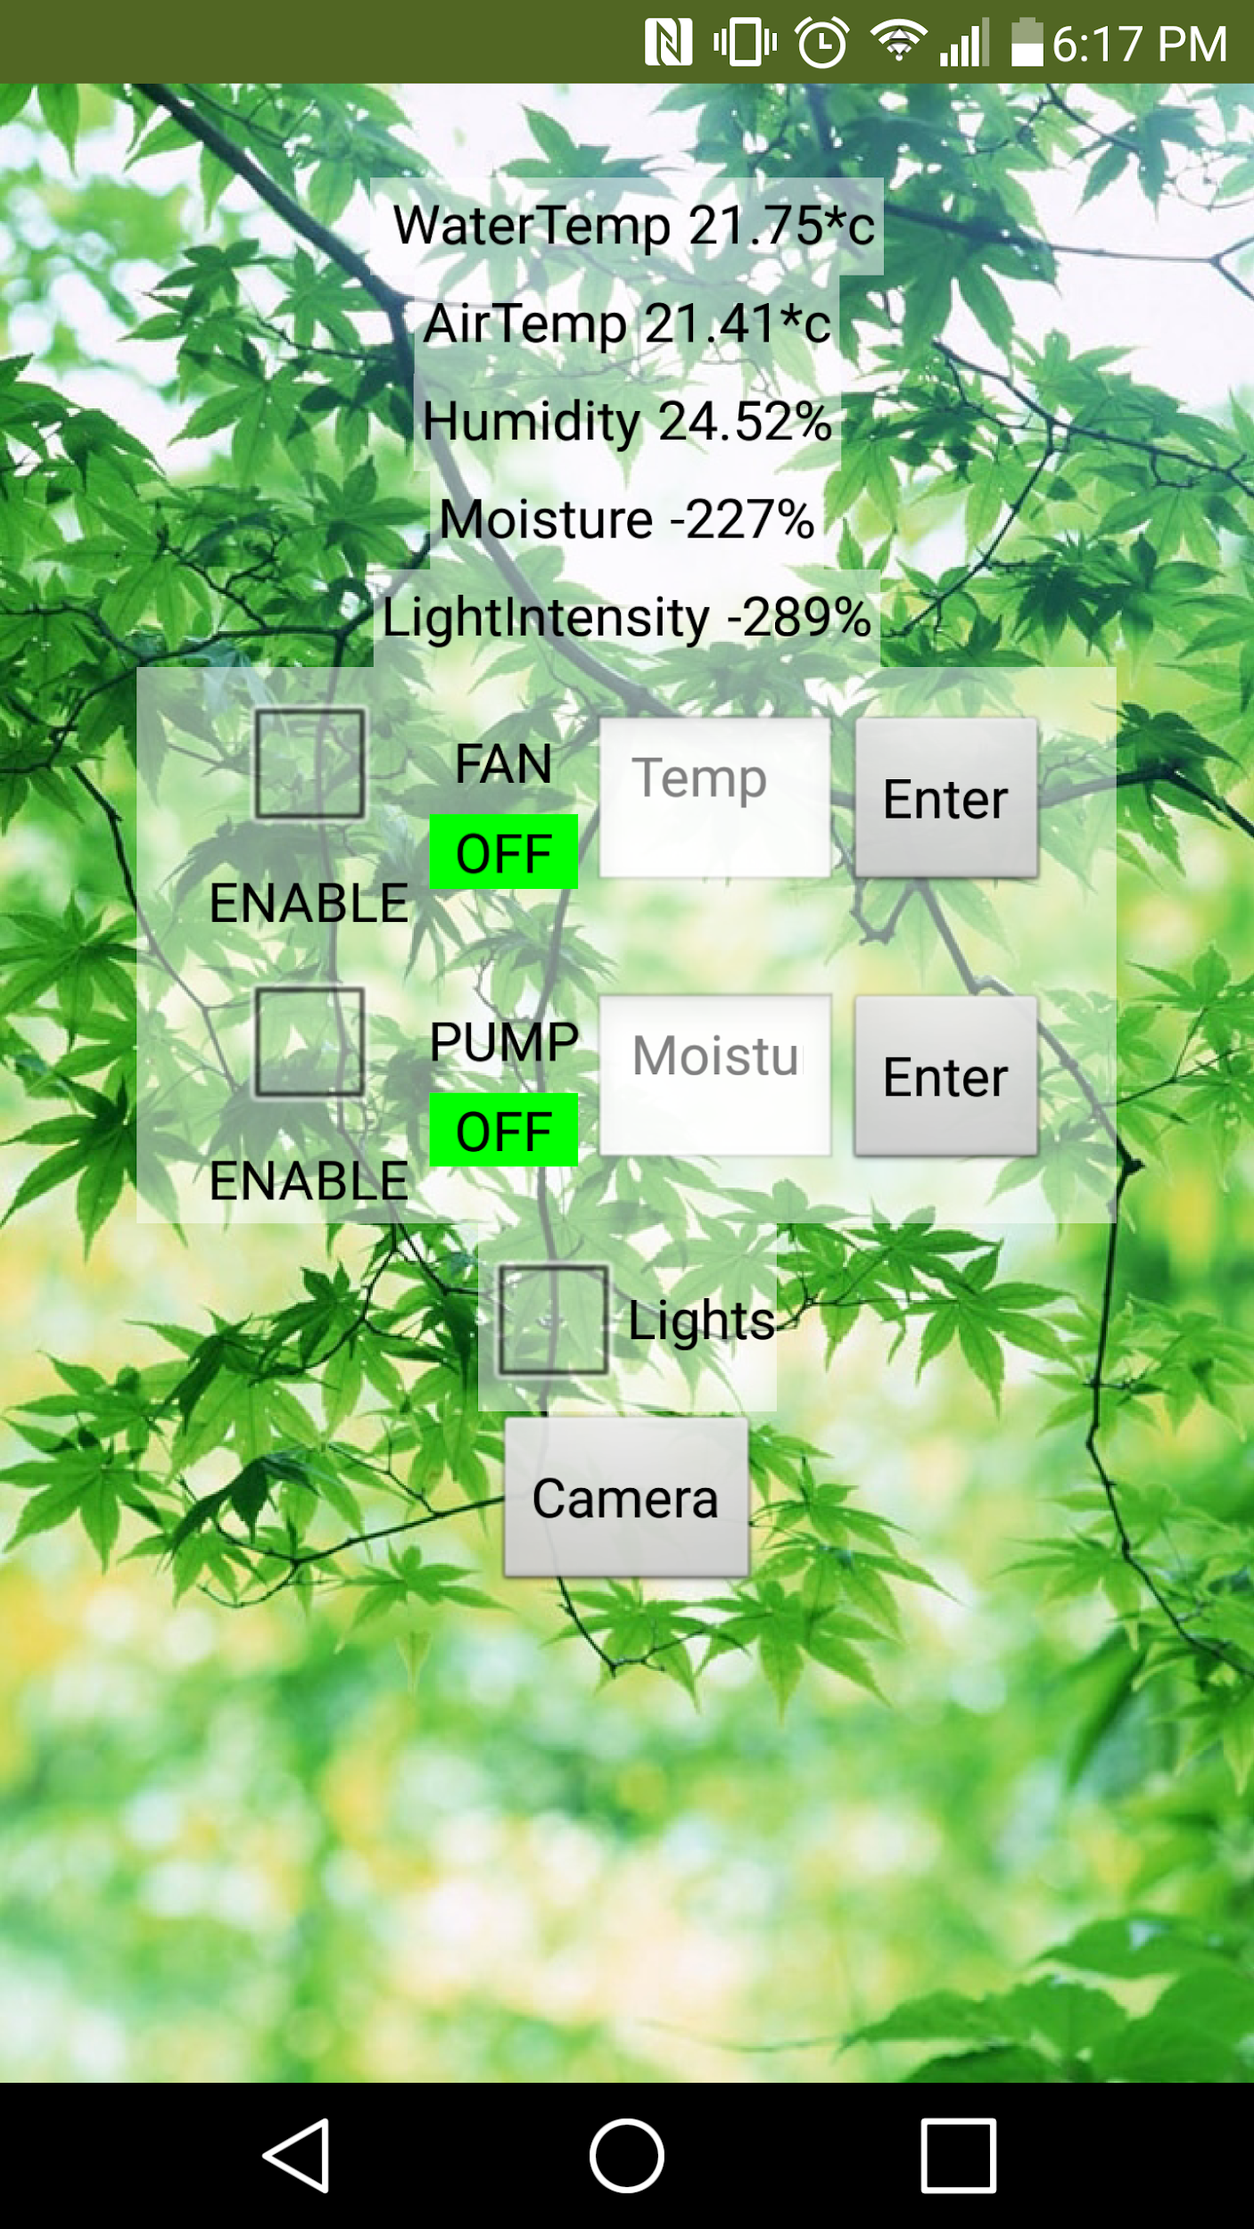

Figure 8: Android Phone

# Instructions

## Set Up

### Hardware

Figure : Open Monitor with Connections

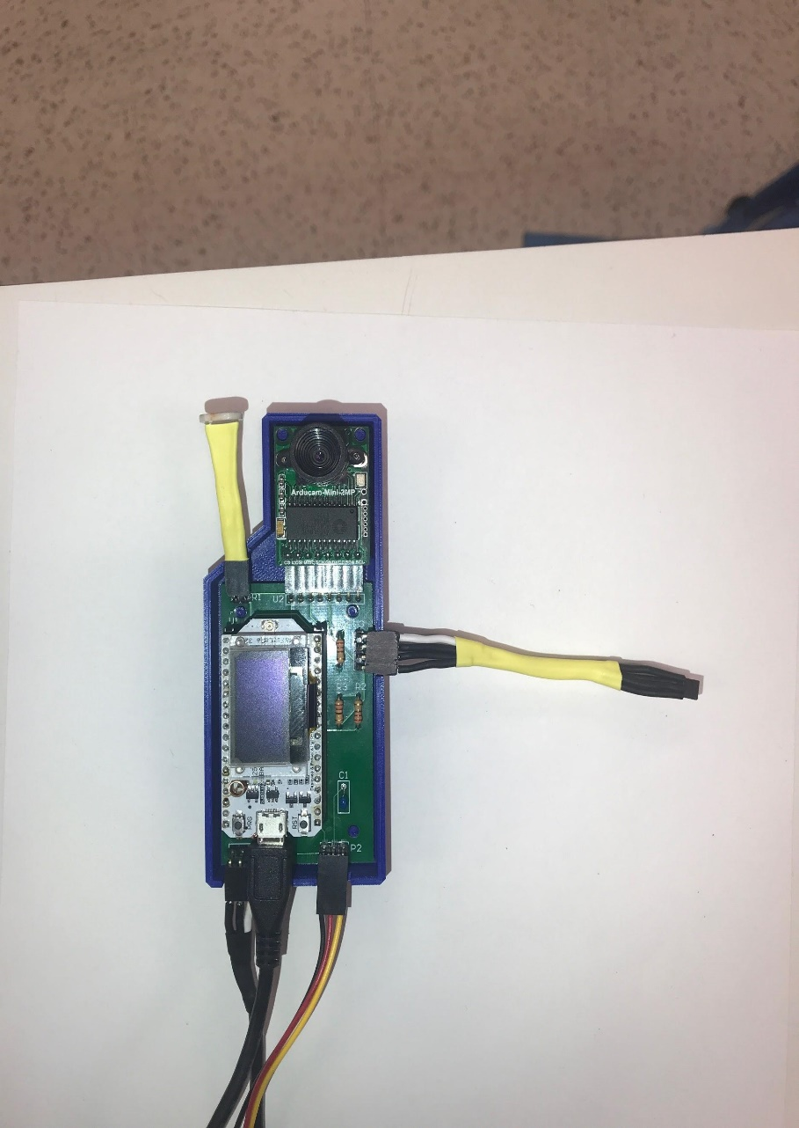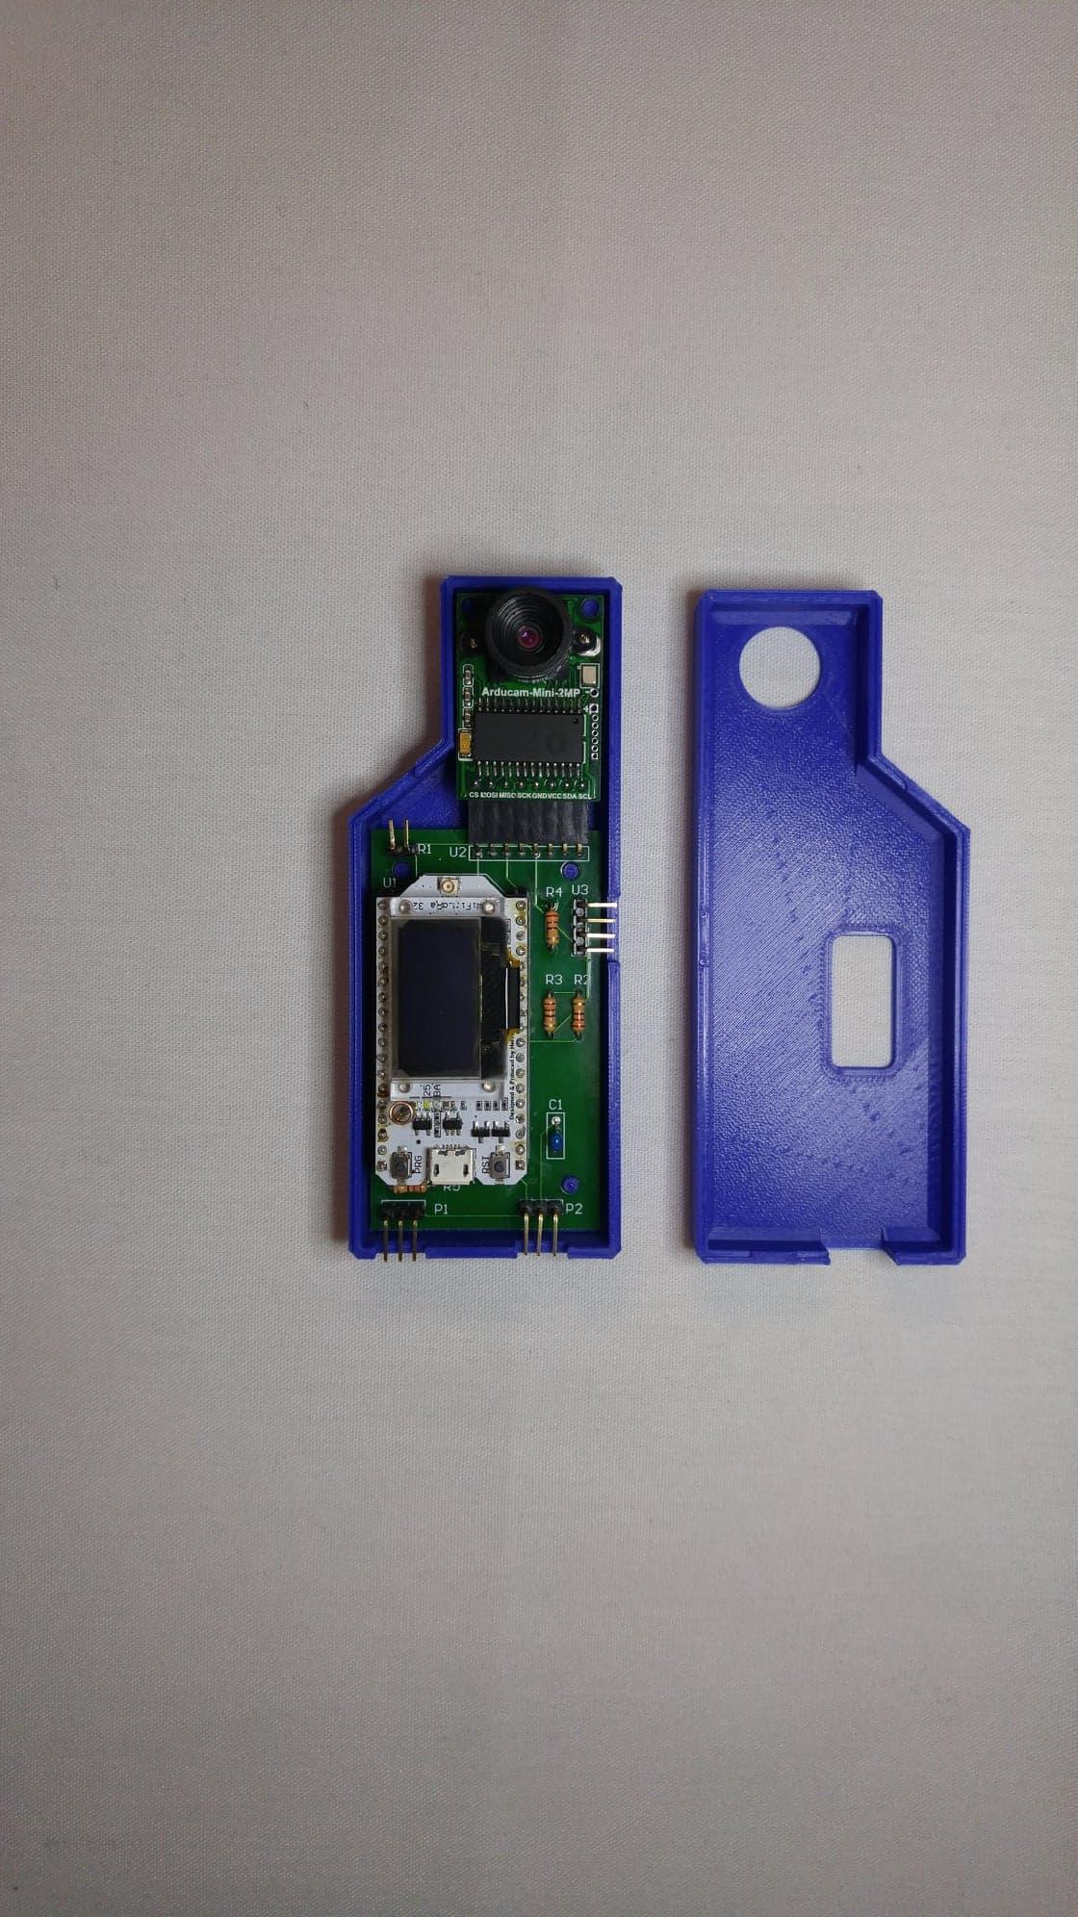

Figure : Monitor with Open Enclosure

Connect all the sensors as shown in the following figures:

1. Attach Temperature/Humidity sensor

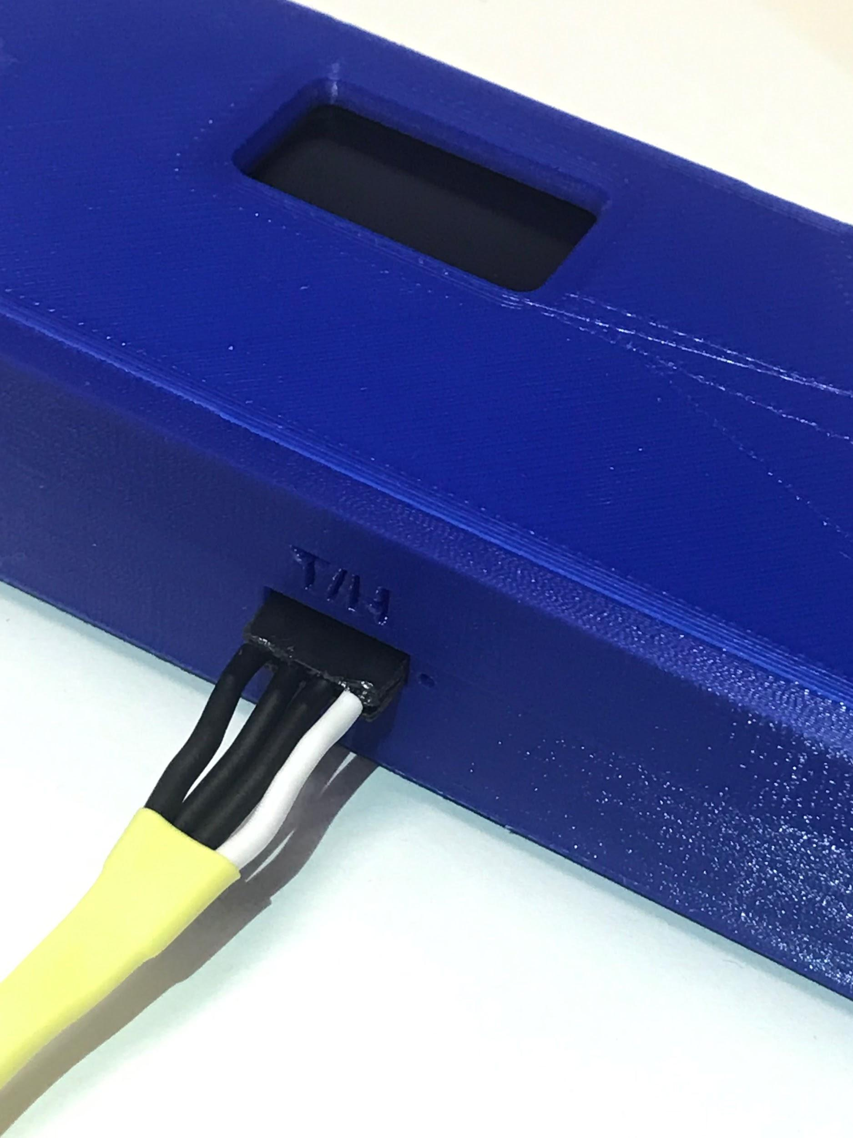

Figure 11: Temp/Humidity Sensor Connection

1. Attach Moisture Sensor

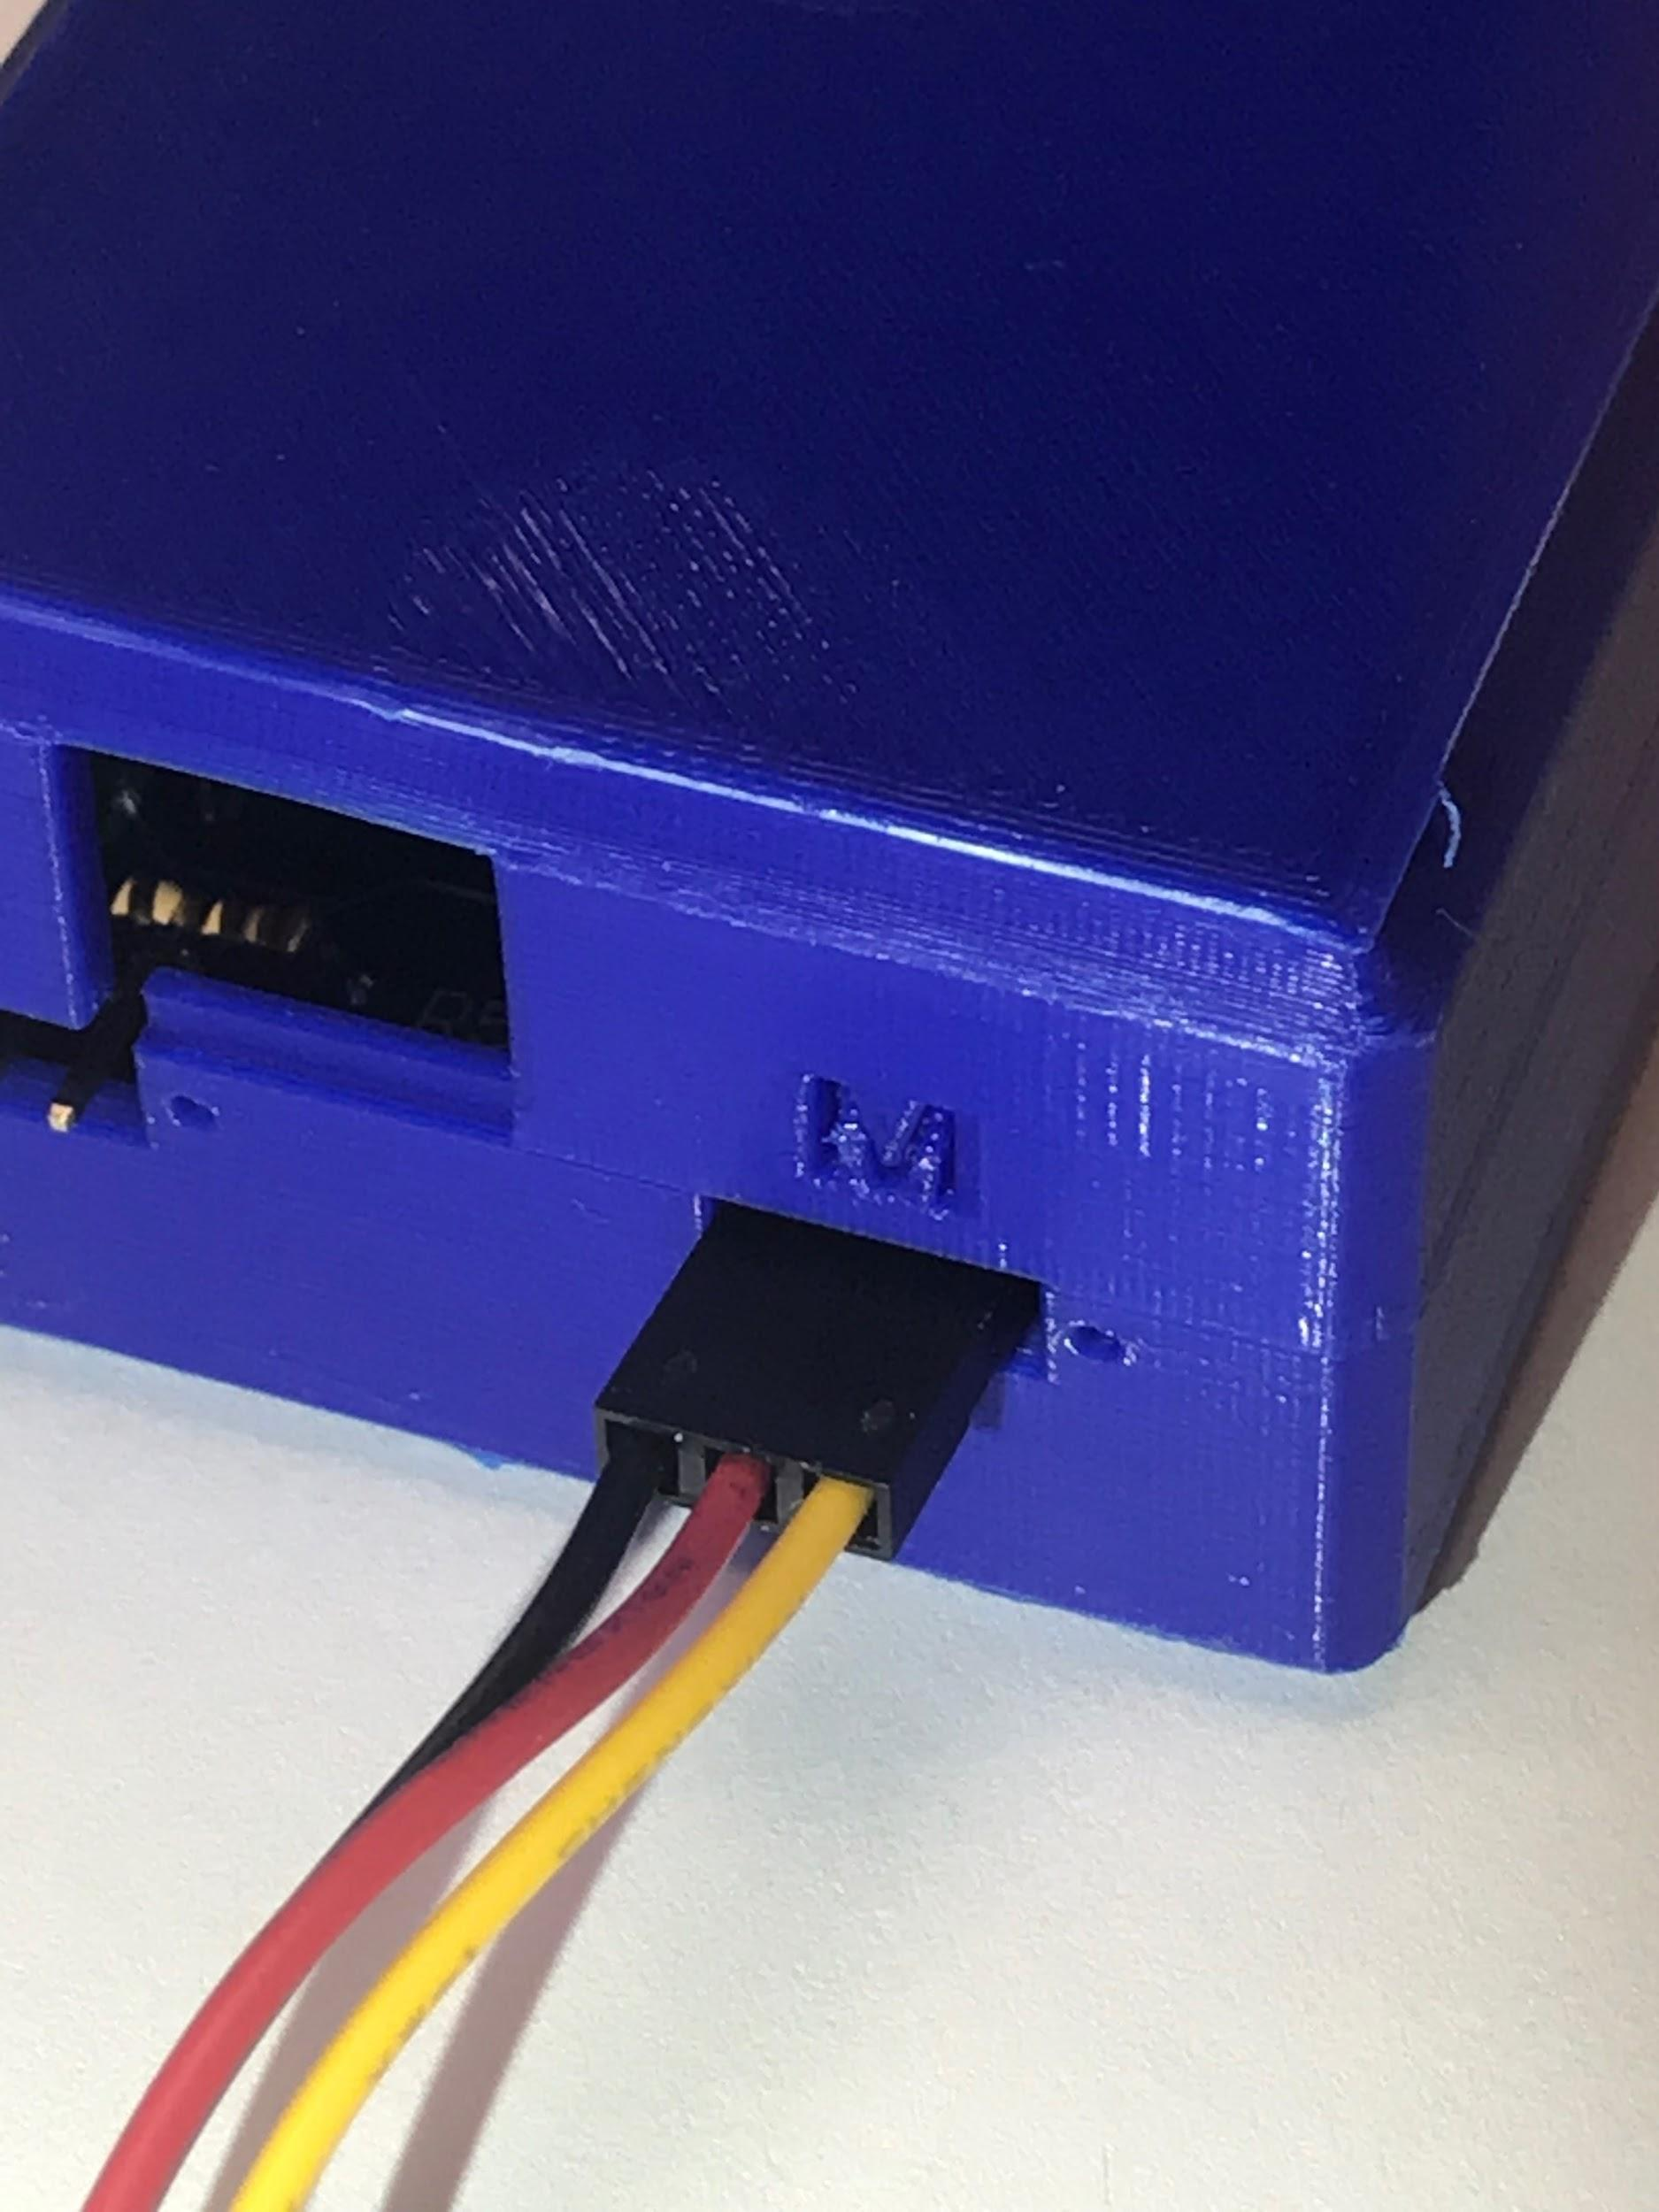

Figure 12: Moisture Sensor Connection

1. Attach Water Temperature sensor

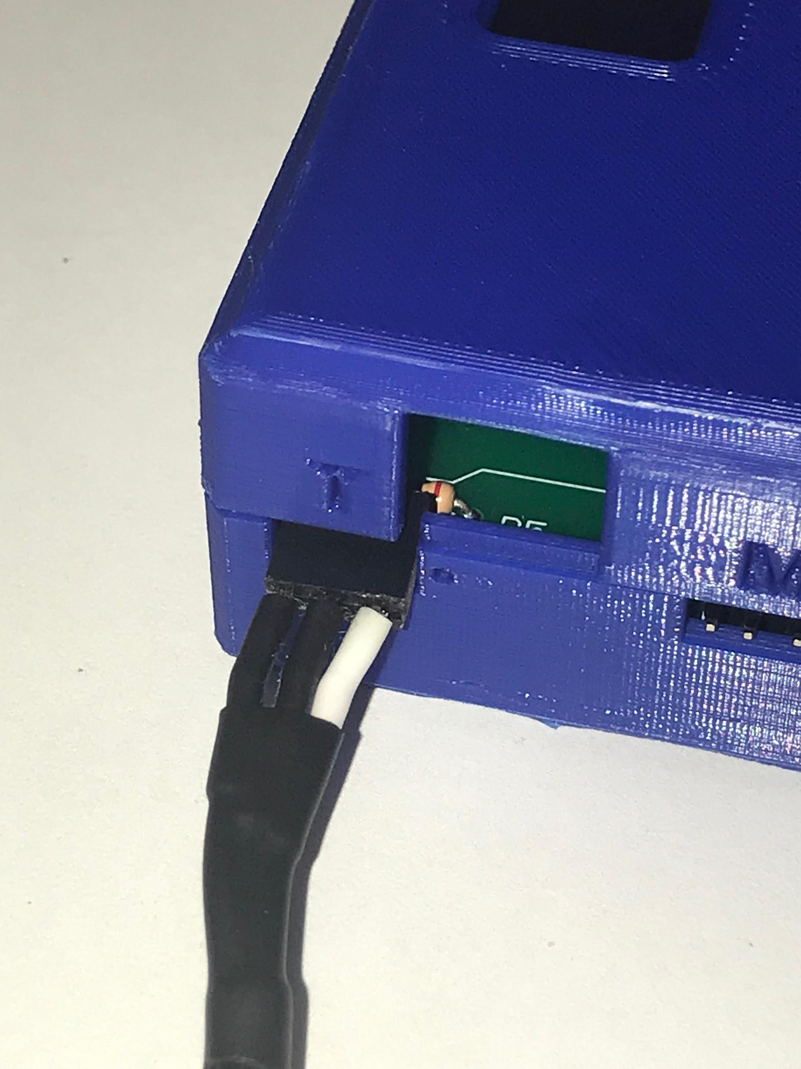

Figure 13: Water Temp Sensor Connection

1. Attach Light Intensity sensor

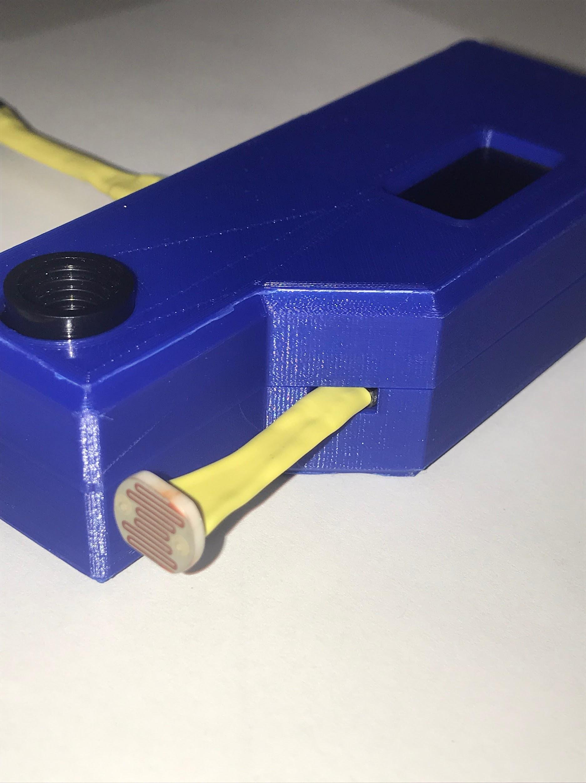

1. Attach Micro USB Cable

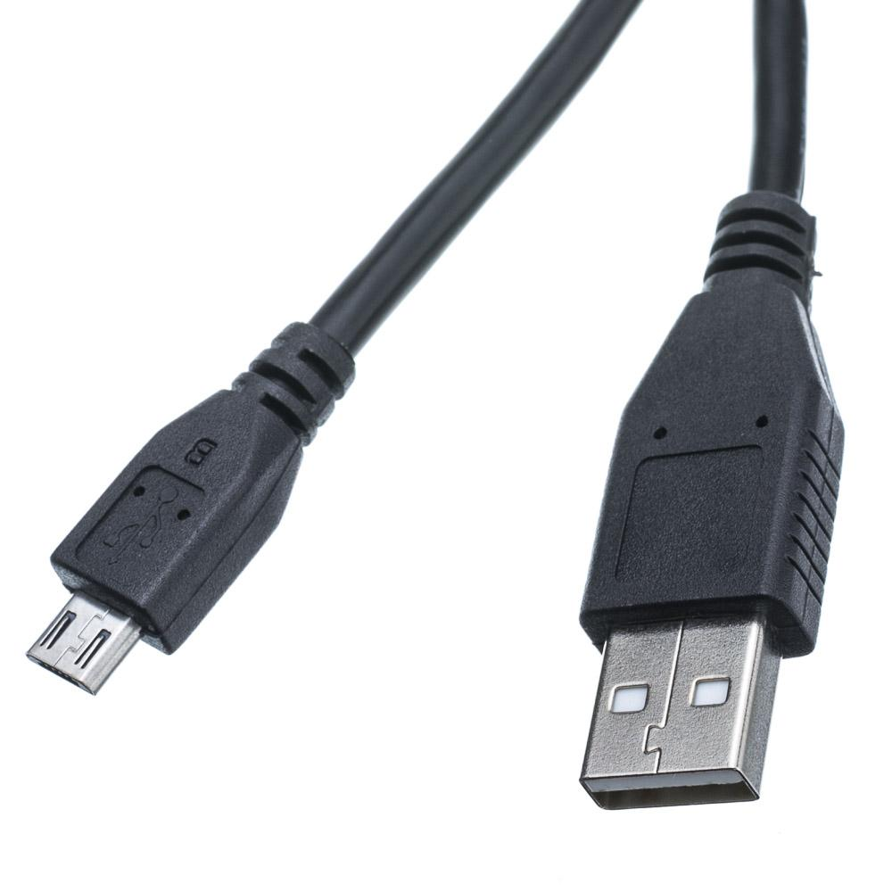

Figure 14: Micro USB Plug

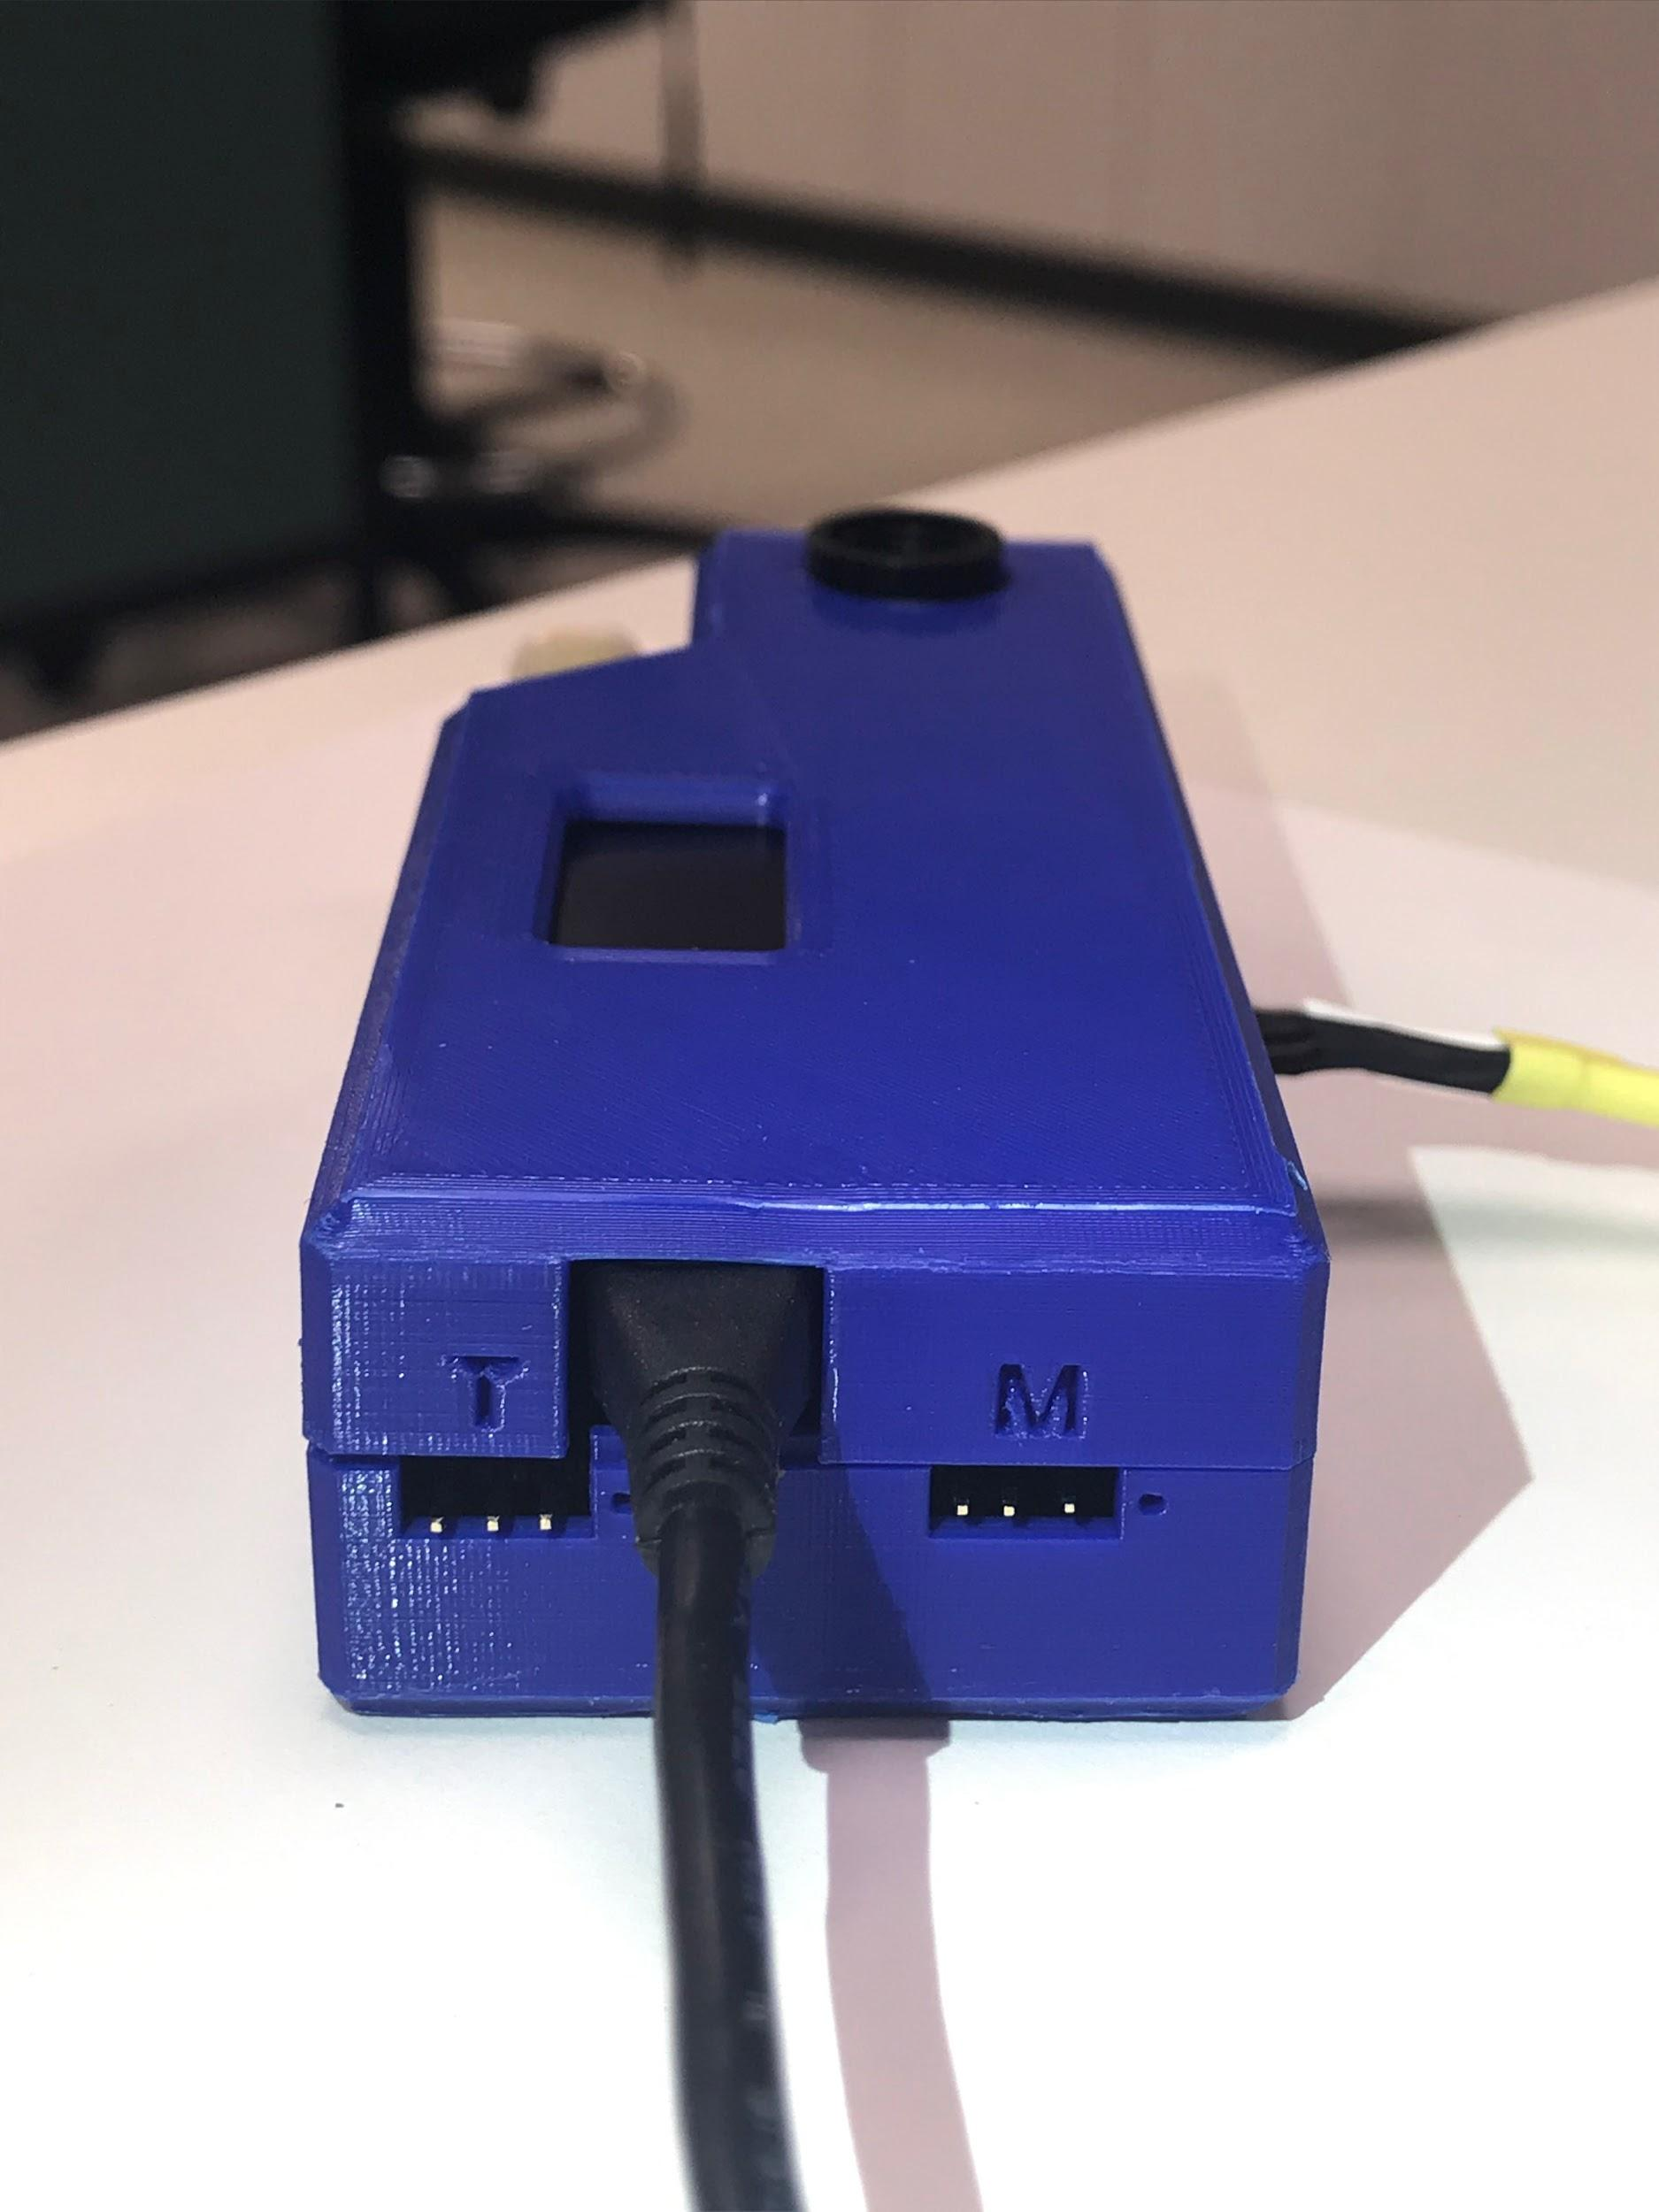

Figure 15: Micro USB Connection

### Software

1. Go to [www.arduino.cc](http://www.arduino.cc). 

Figure 16: Arduino Website

1. Download the latest version of arduino.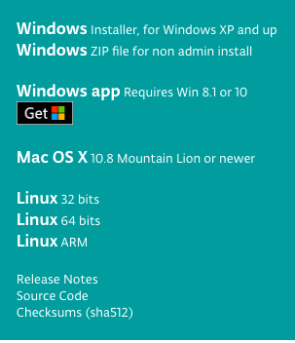

Figure 17: Arduino IDE Download

1. Install the arduino on your PC
2. Now, Download the FreshView zip package folder from Github.com.
3. To download the FreshView zip package
4. Search [**https://github.com/FreshView/FreshView**](https://github.com/FreshView/FreshView)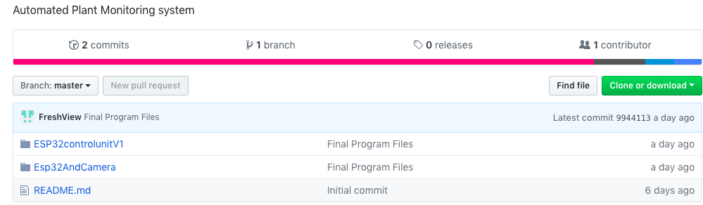

Figure 18: FreshView Github

1. Unzip the folder and open the ESP32 and Camera program under Arduino IDE once the package is downloaded
2. Connect the monitoring unit to your computer.
3. Change the Wifi address and password to your home network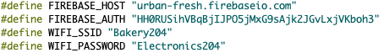

Figure 19: Arduino Code SSID and Password

1. Save the program
2. Make sure you choose the right port before actually uploading the programming the unit.
3. 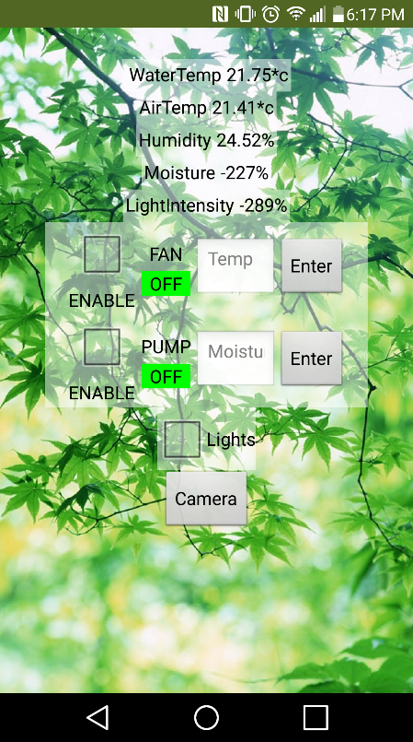Upload the code.

Figure : Fresh View App Interface

1. From the downloaded FreshView zip package find FreshView[1].
2. Transfer the downloaded file to your android mobile phone and run the application.
3. Live data can be seen on the screen (Figure 20)
4. Enter your desired temperature and press enter.
5. If the desired temperature is less than the actual temperature, the fan will automatically turn on.
6. Enter the desired moisture content and press enter.
7. If the desired moisture content is less than the actual moisture content, the pump will turn on to irrigate the plants and increase the moisture level.

## 

## Access to Online storage

1. Go to [www.firebase.google.com](http://www.firebase.google.com)

Figure 21: Firebase Website

1. Select “Get Started” and sign in or sign up using your google account.
2. Once you have been given access to the account, go to the **console** and choose the **Urban Fresh Sleep Mode** project. In this you will have access to the realtime database and logs of the project.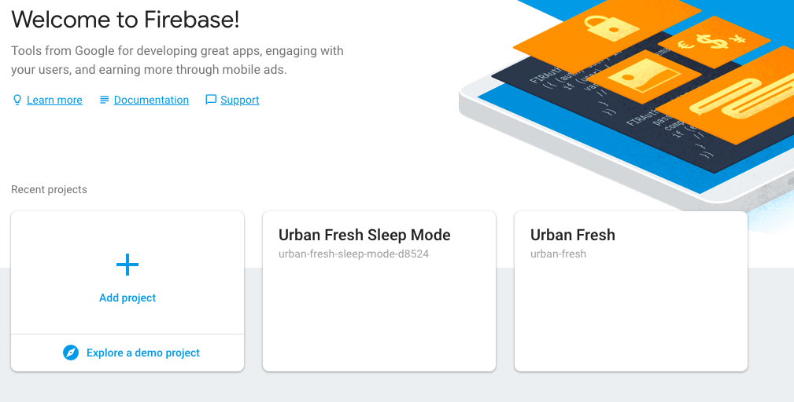

Figure 22: Firebase Console

# Conclusion

The Fresh View monitoring unit provides a unique solution to common growing needs. By provide the right information at the right time, Fresh View can help optimize yields, and prevent crop failure. The system is simple to set up and effortless to use. As long as the app is installed you will have access to essential plant data and an immediate visual link to the growing environment. If any issues arise in the setup or operation of this device, you can contact the Urban Fresh team at:

**Pawan Kumar**

[pawancan59@gmail.com](mailto:pawancan59@gmail.com)

**Solomon Lindsay**

[sol.lauder.lindsay@gmail.com](mailto:sol.lauder.lindsay@gmail.com)

**Varun Prabhakar**

[varunprabhakar31@gmail.com](mailto:varunprabhakar31@gmail.com)